This circuit is used to demonstrate the advantages and disadvantages of different programming languages to control the Raspberry Pi GPIO.

# Ingredients

* Four standard LEDs
* Four 220 ohm resistors
* One normally open pushbutton
* Jumper wires and breadboard
* Any Raspberry Pi

# Circuit Diagram

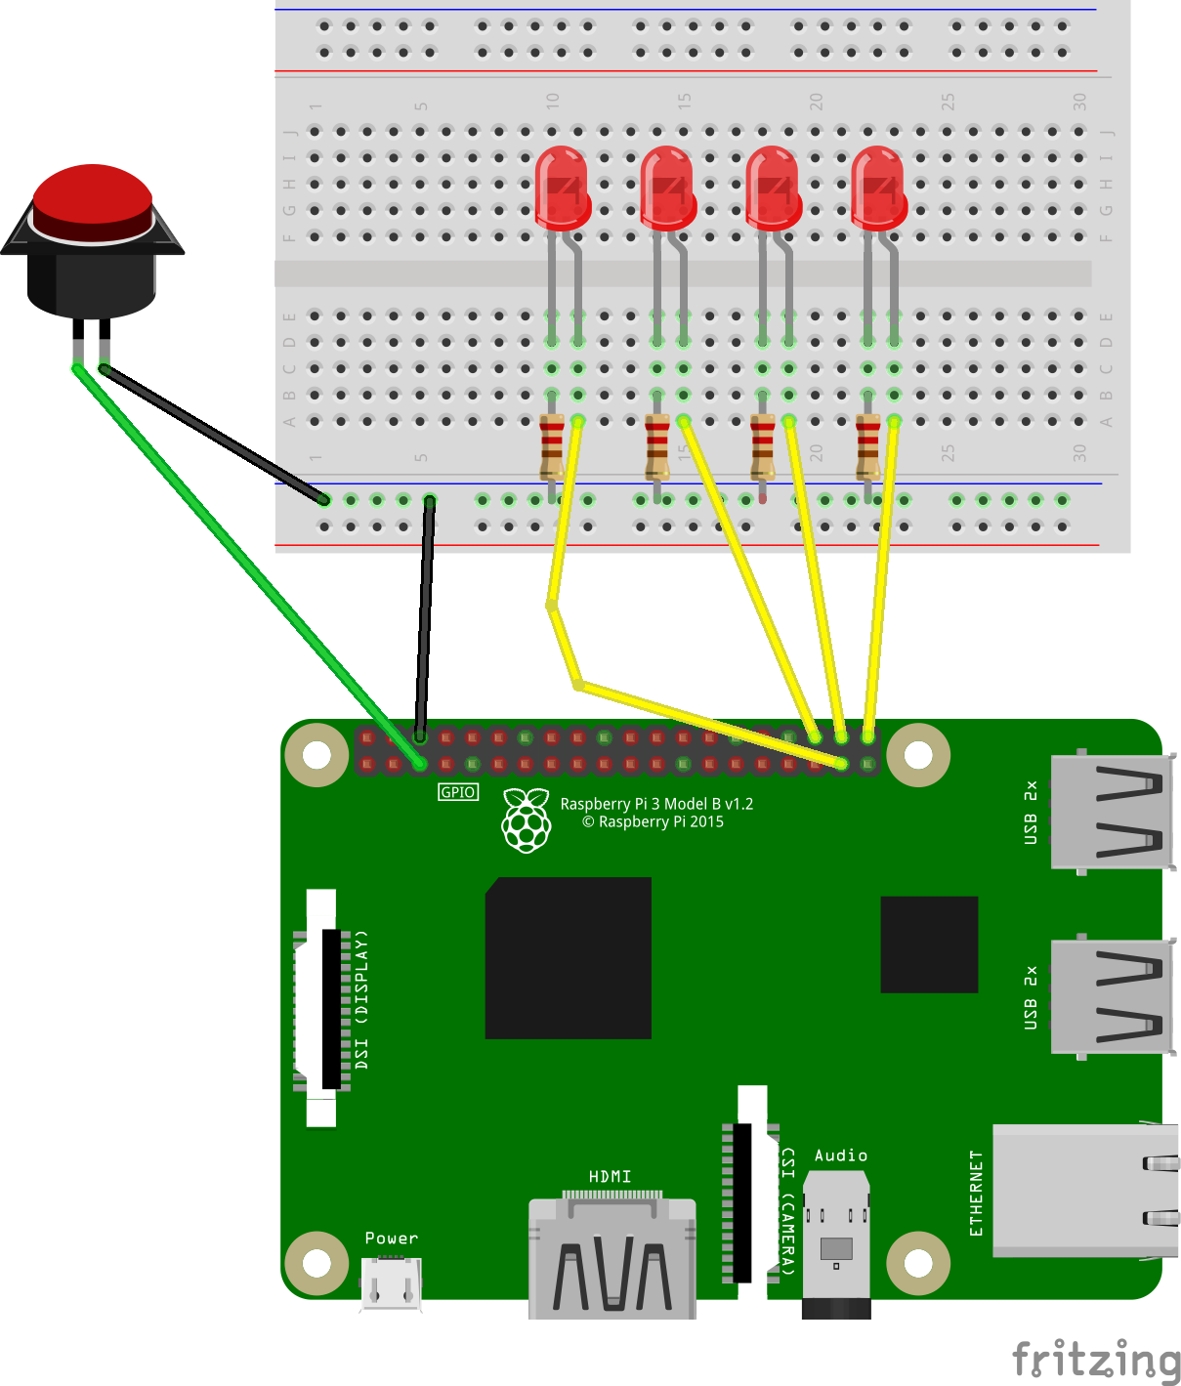

# Circuit Description

|  |  |  |  |
| --- | --- | --- | --- |
| **Description** | **GPIO Board Pin** | **GPIO BCM** |  |
| Ground | 6 | gnd | Breadboard ground rail |
| Reset Button + | 5 | Bcm 3 | One side of pushbutton |
| Reset Button - |  |  | Pushbutton to ground rail |
| Ones position binary light | 40 | Bcm 21 | LED 1 Anode |
| Twos position binary light | 38 | Bcm 20 | LED 2 Anode |
| Fours position binary light | 36 | Bcm 16 | LED 3 Anode |
| Eights position binary light | 37 | Bcm 26 | LED 4 Anode |
| LED ground cathode |  |  | 220 ohm resistor between each LED cathode and Ground |